

**Module Code & Module Title**

**CS6P05NI Final Year Project**

**Assessment Weightage & Type**

**10% FYP Project Logs**

**Year and Semester**

**2022 Spring**

**Student Name: Abhishek Rokaya**

**London Met ID: 19030695**

**College ID: NP01CP4A190164**

**Internal Supervisor: Mohit Sharma**

**External Supervisor: Ankit Tandukar**

**Assignment Due Date: 27th April 2022**

**Assignment Submission Date: 27th April 2022**

*I confirm that I understand my coursework needs to be submitted online via Google Classroom under the relevant module page before the deadline in order for my assignment to be accepted and marked. I am fully aware that late submissions will be treated as non-submission and a marks of zero will be awarded.*

Table of Contents

1. Log 1 1

2. Log 2 2

3. Log 3 3

4. Log 4 4

5. Log 5 5

6. Log 6 6

7. Log 7 7

8. Log 8 8

9. Log 9 9

10. Log 10 10

11. Log 11 11

12. Log 12 12

13. Log 13 13

14. Log 14 14

15. Log 15 15

16. Log 16 16

17. Log 17 17

# 1. Log 1

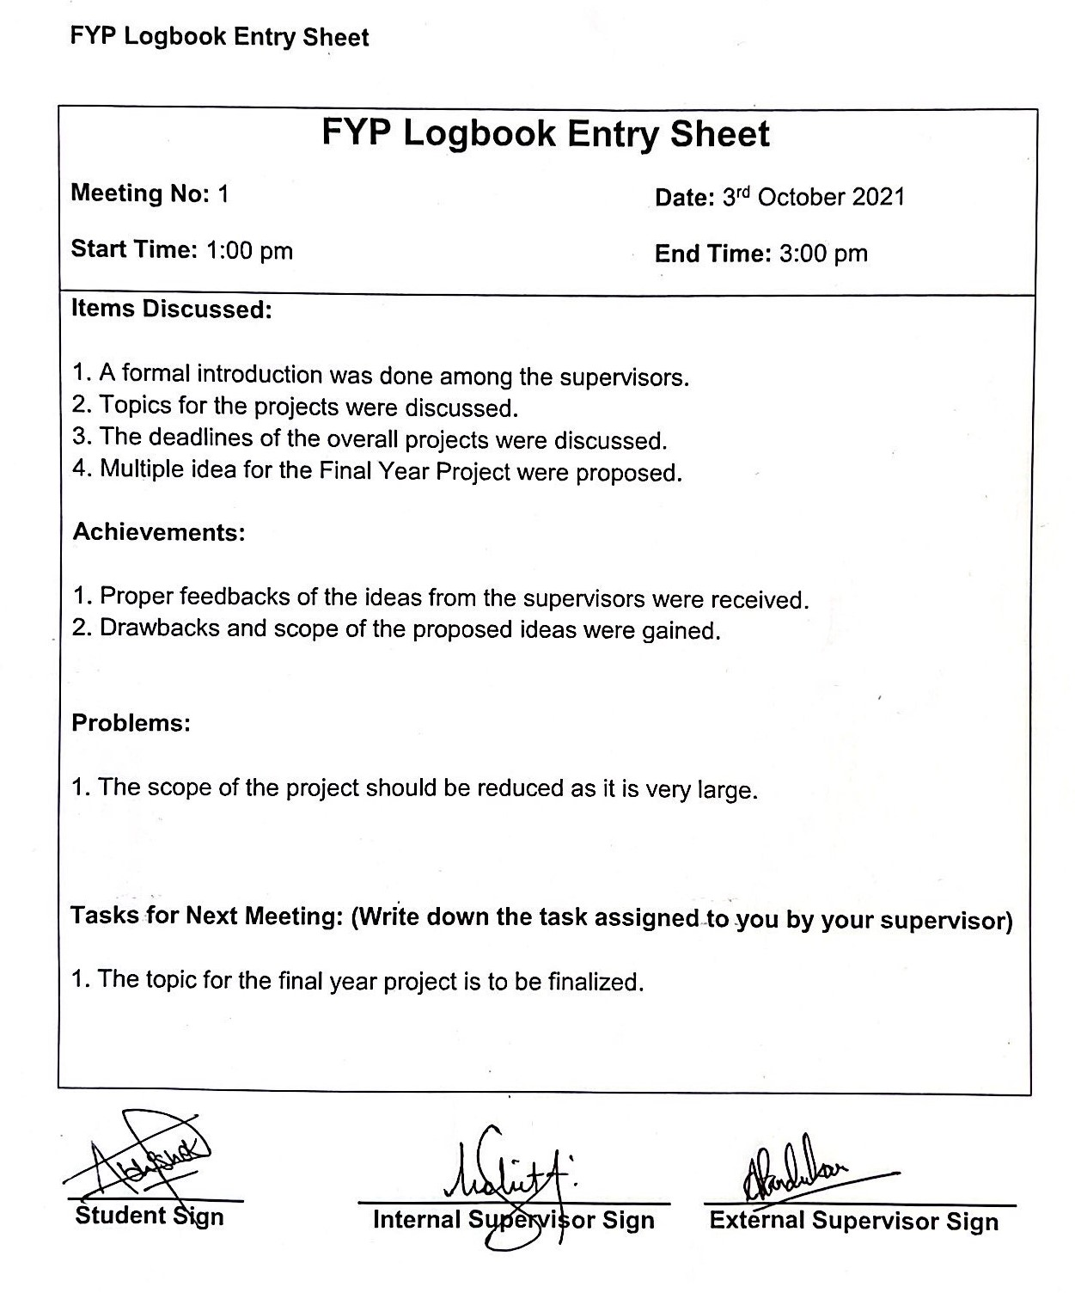

# 2. Log 2

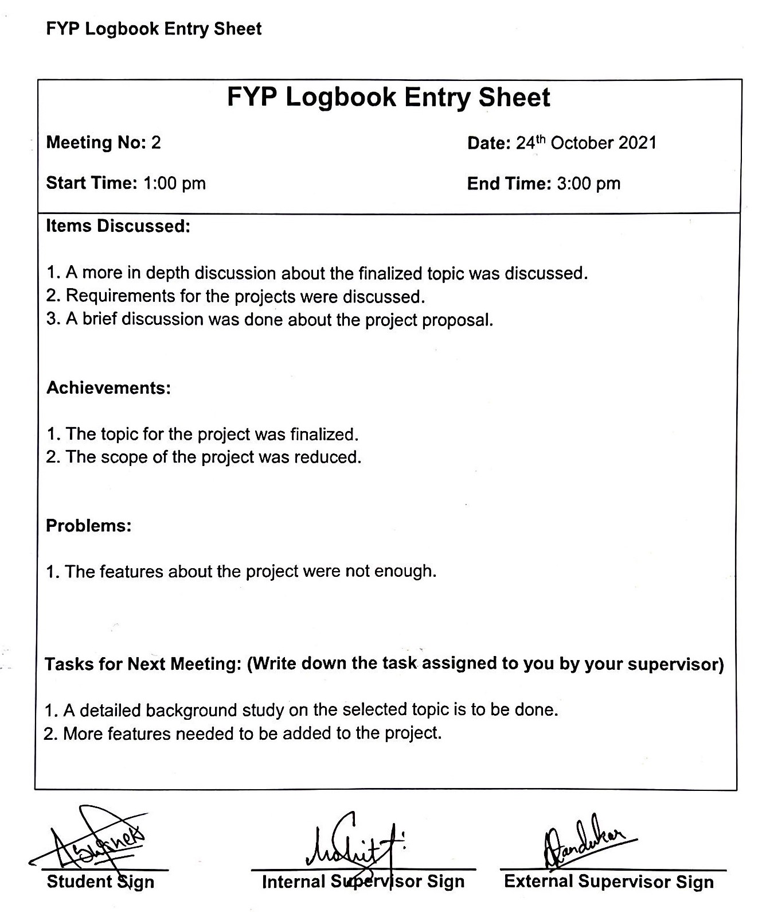

# 3. Log 3

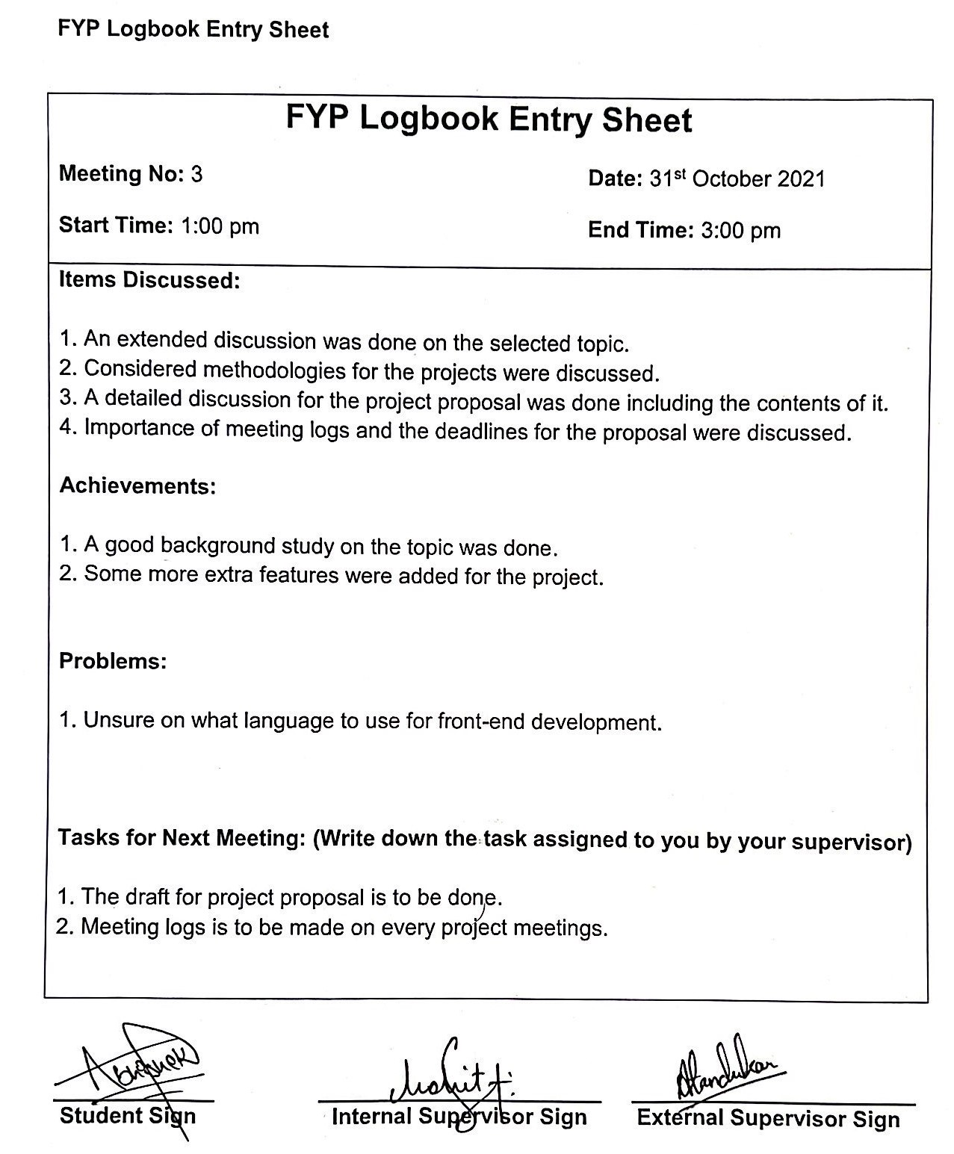

# 4. Log 4

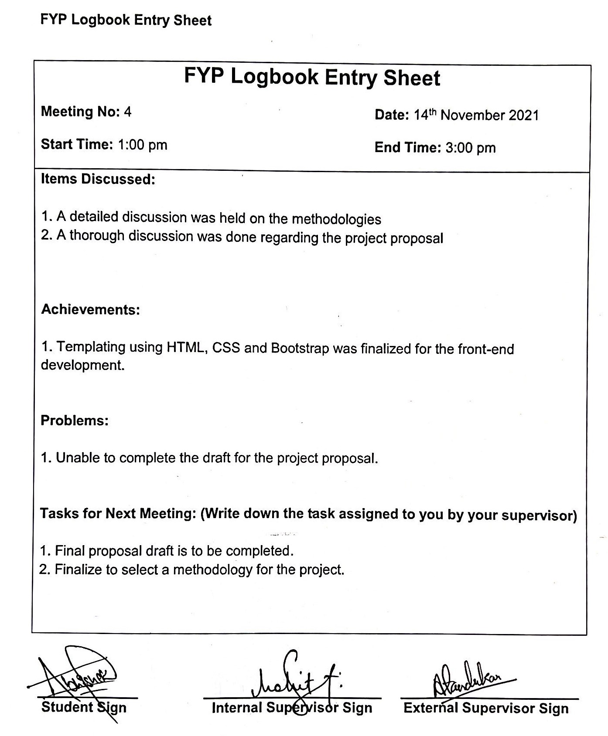

# 5. Log 5

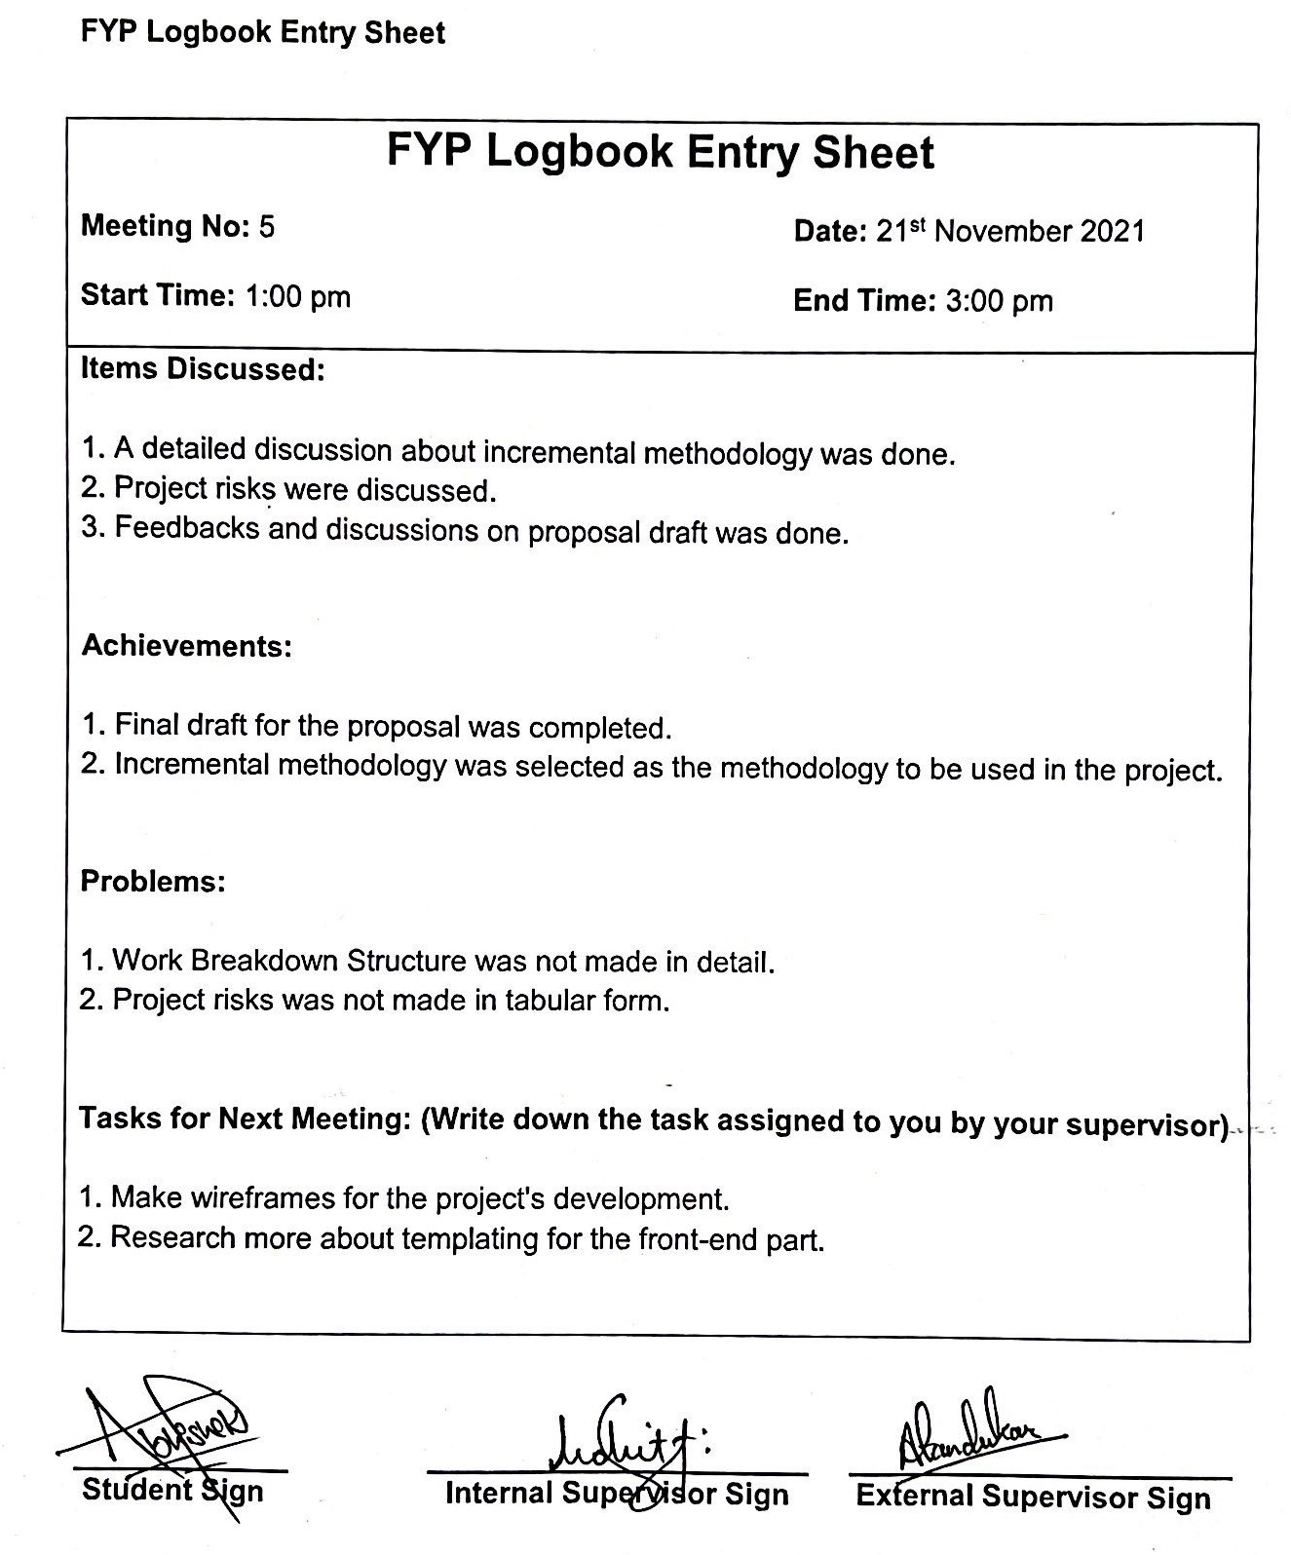

# 6. Log 6

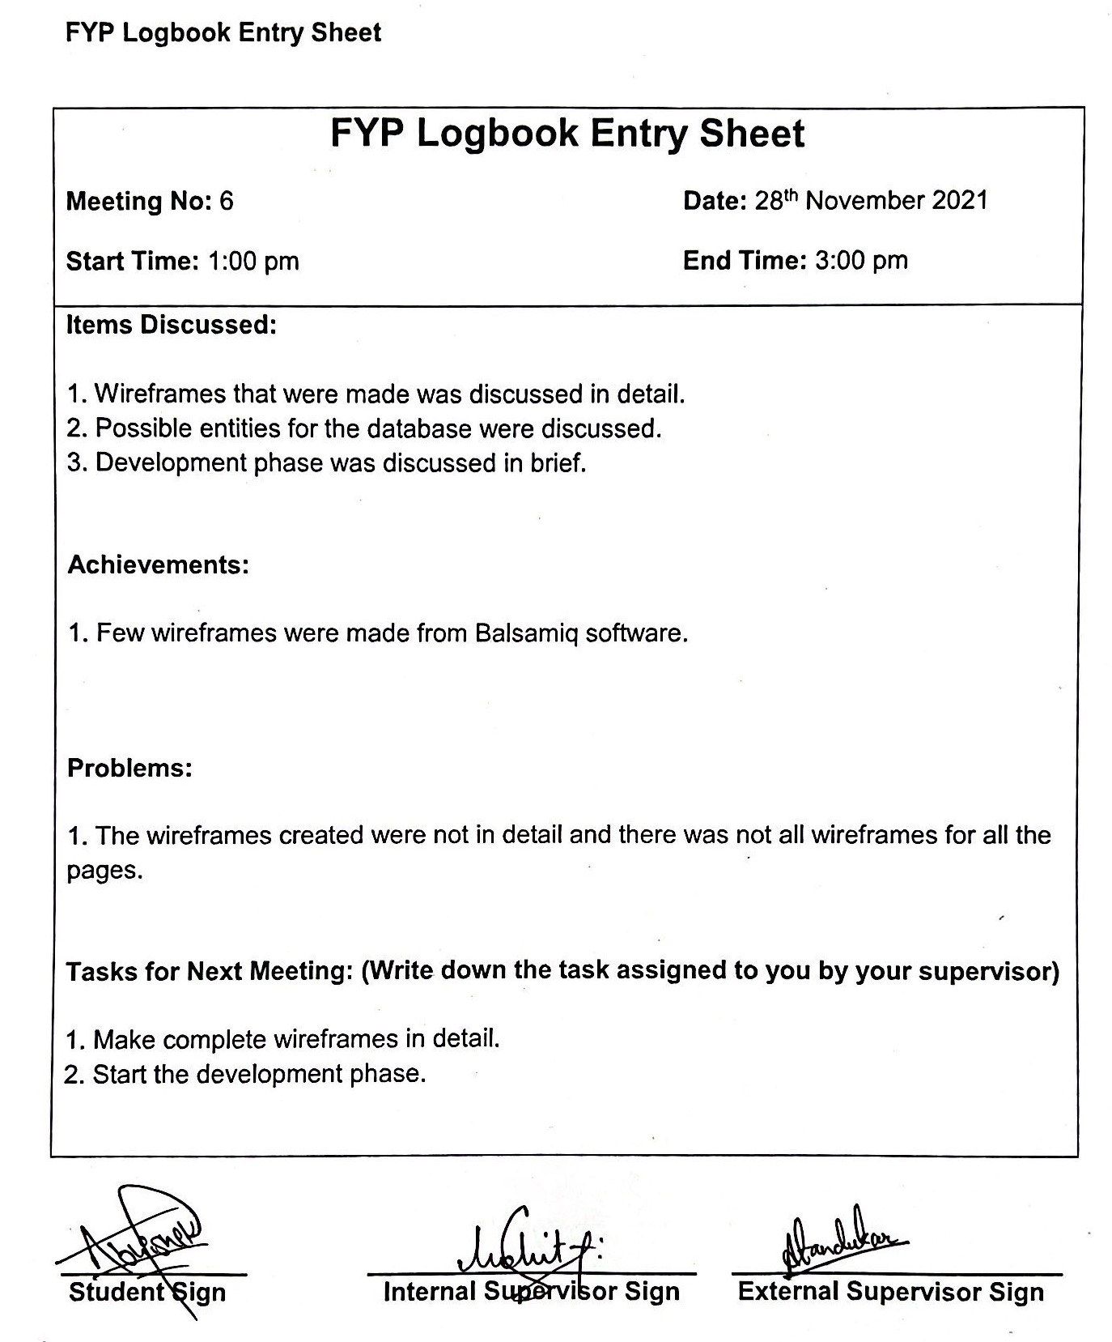

# 7. Log 7

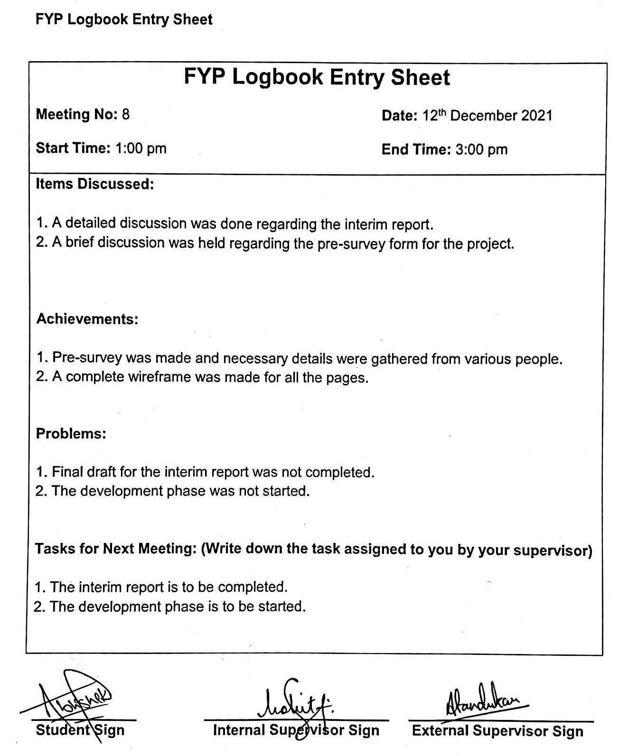

# 8. Log 8

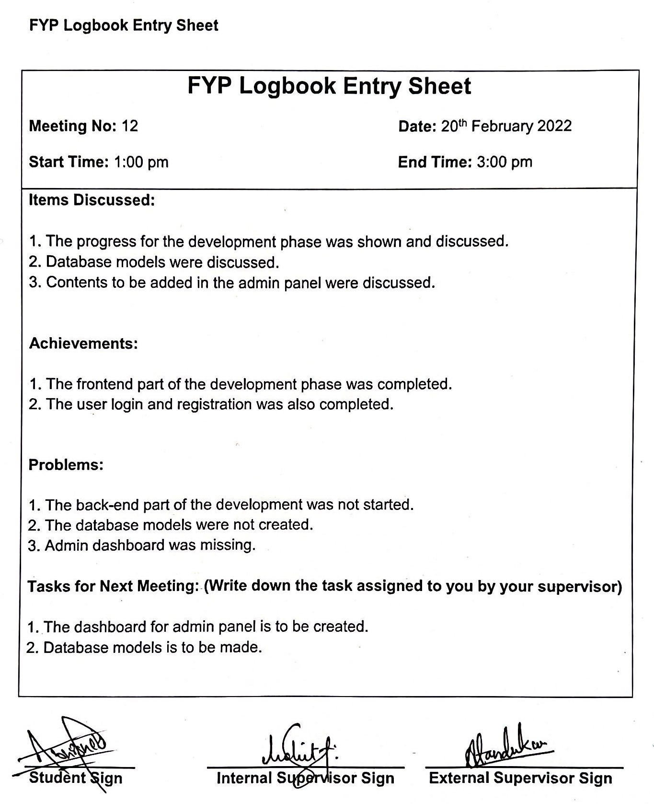

# 9. Log 9

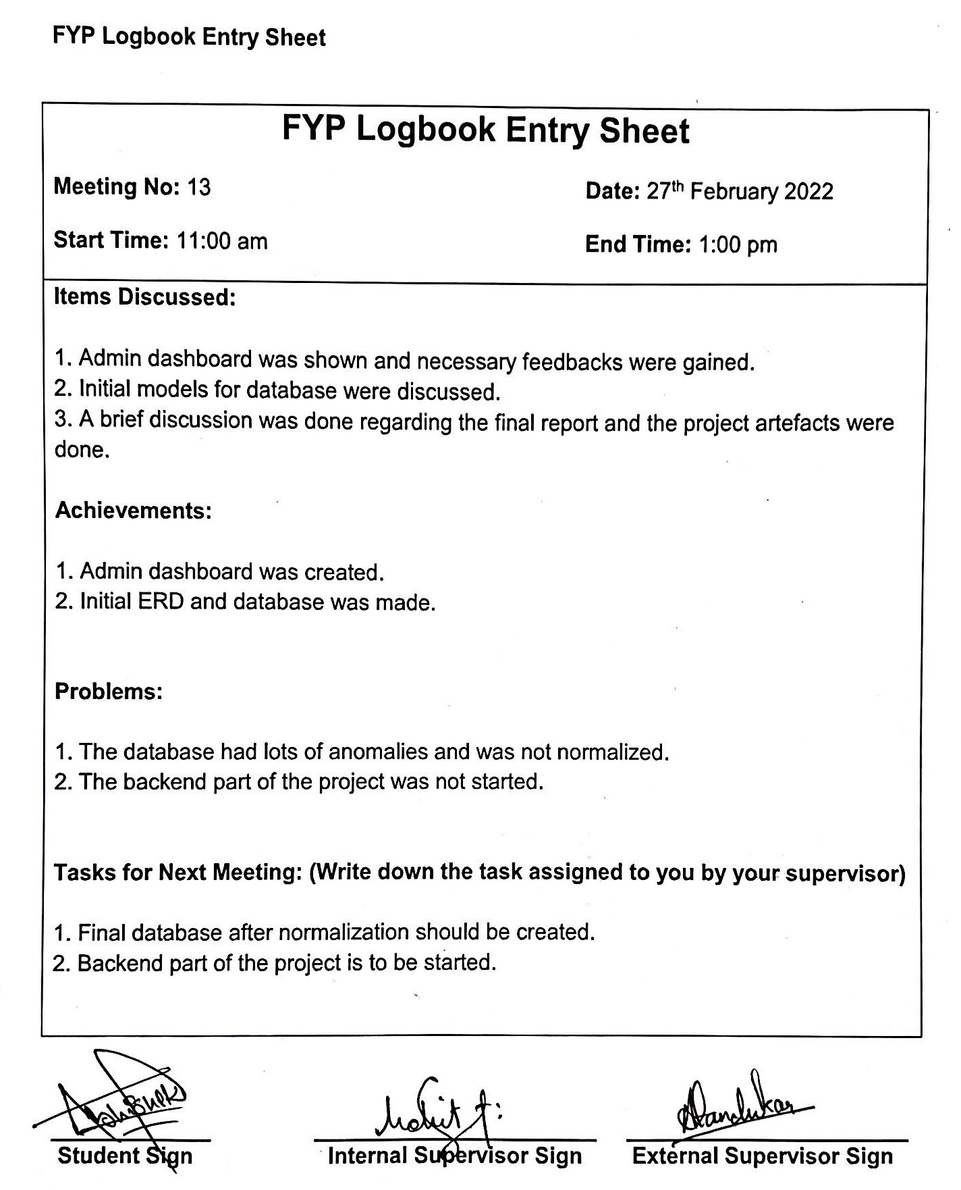

# 10. Log 10

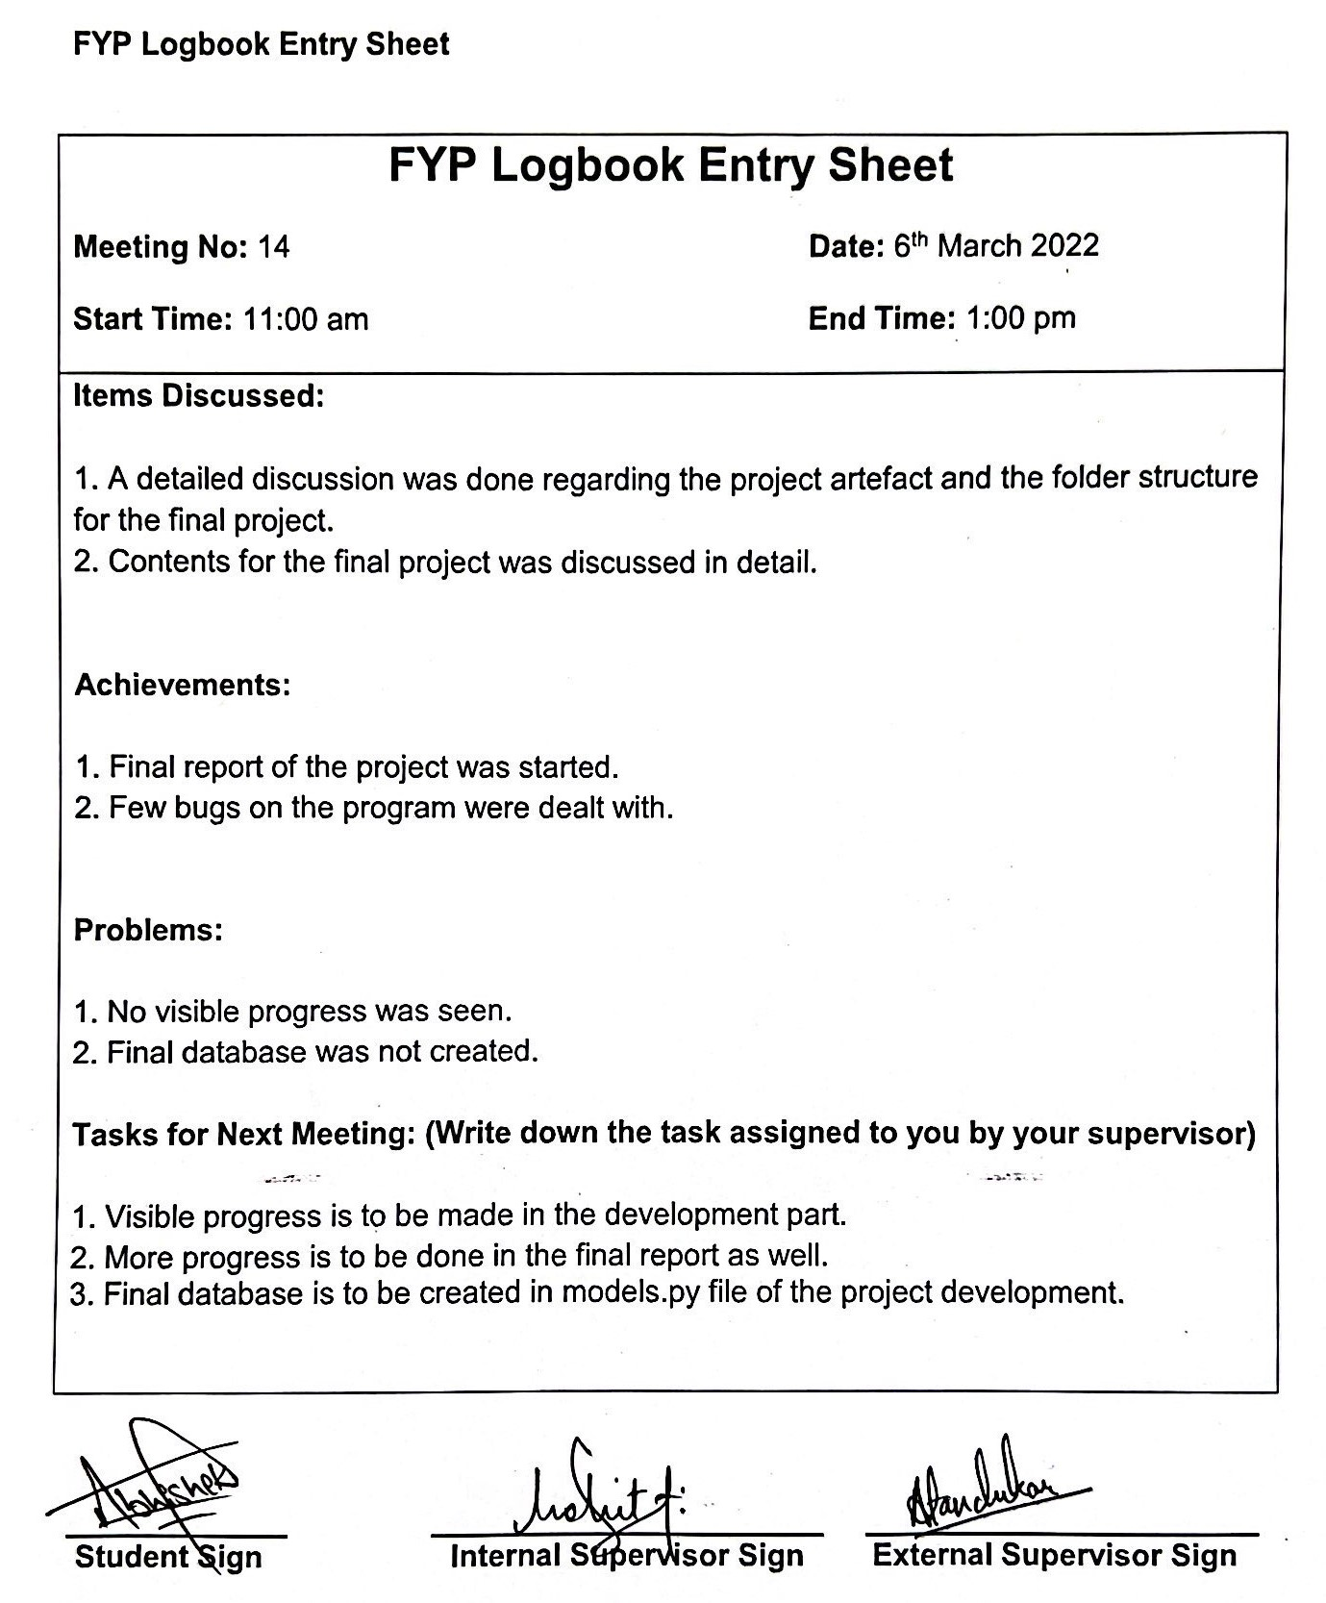

# 11. Log 11

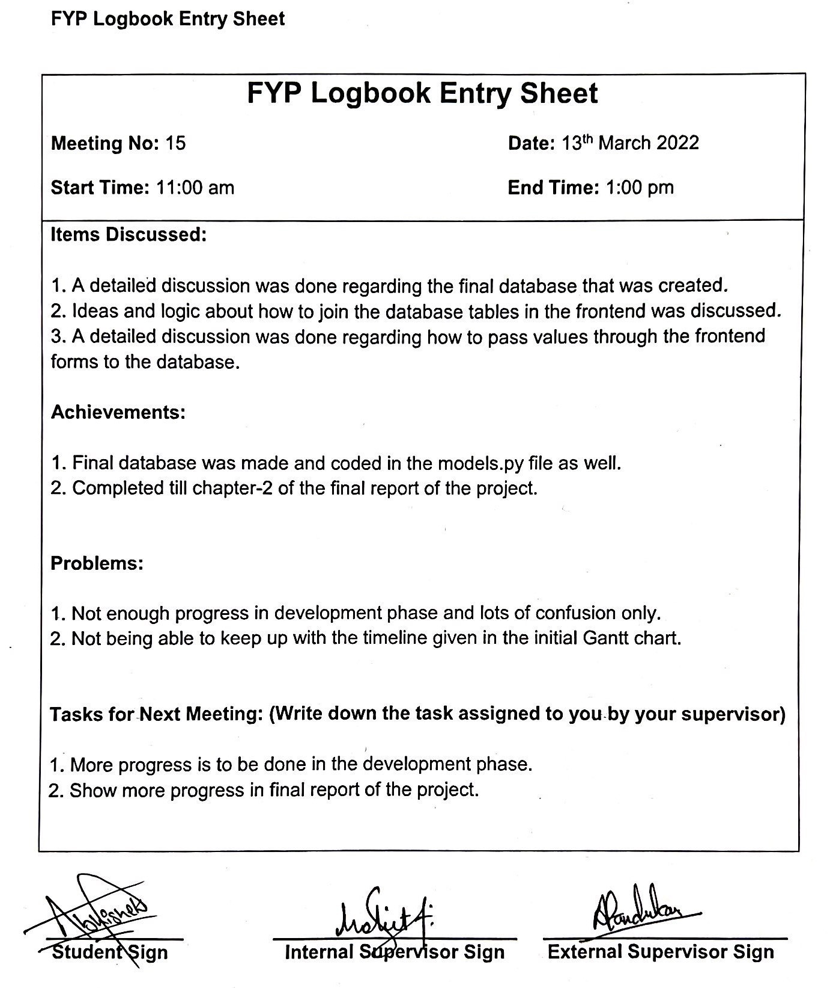

# 12. Log 12

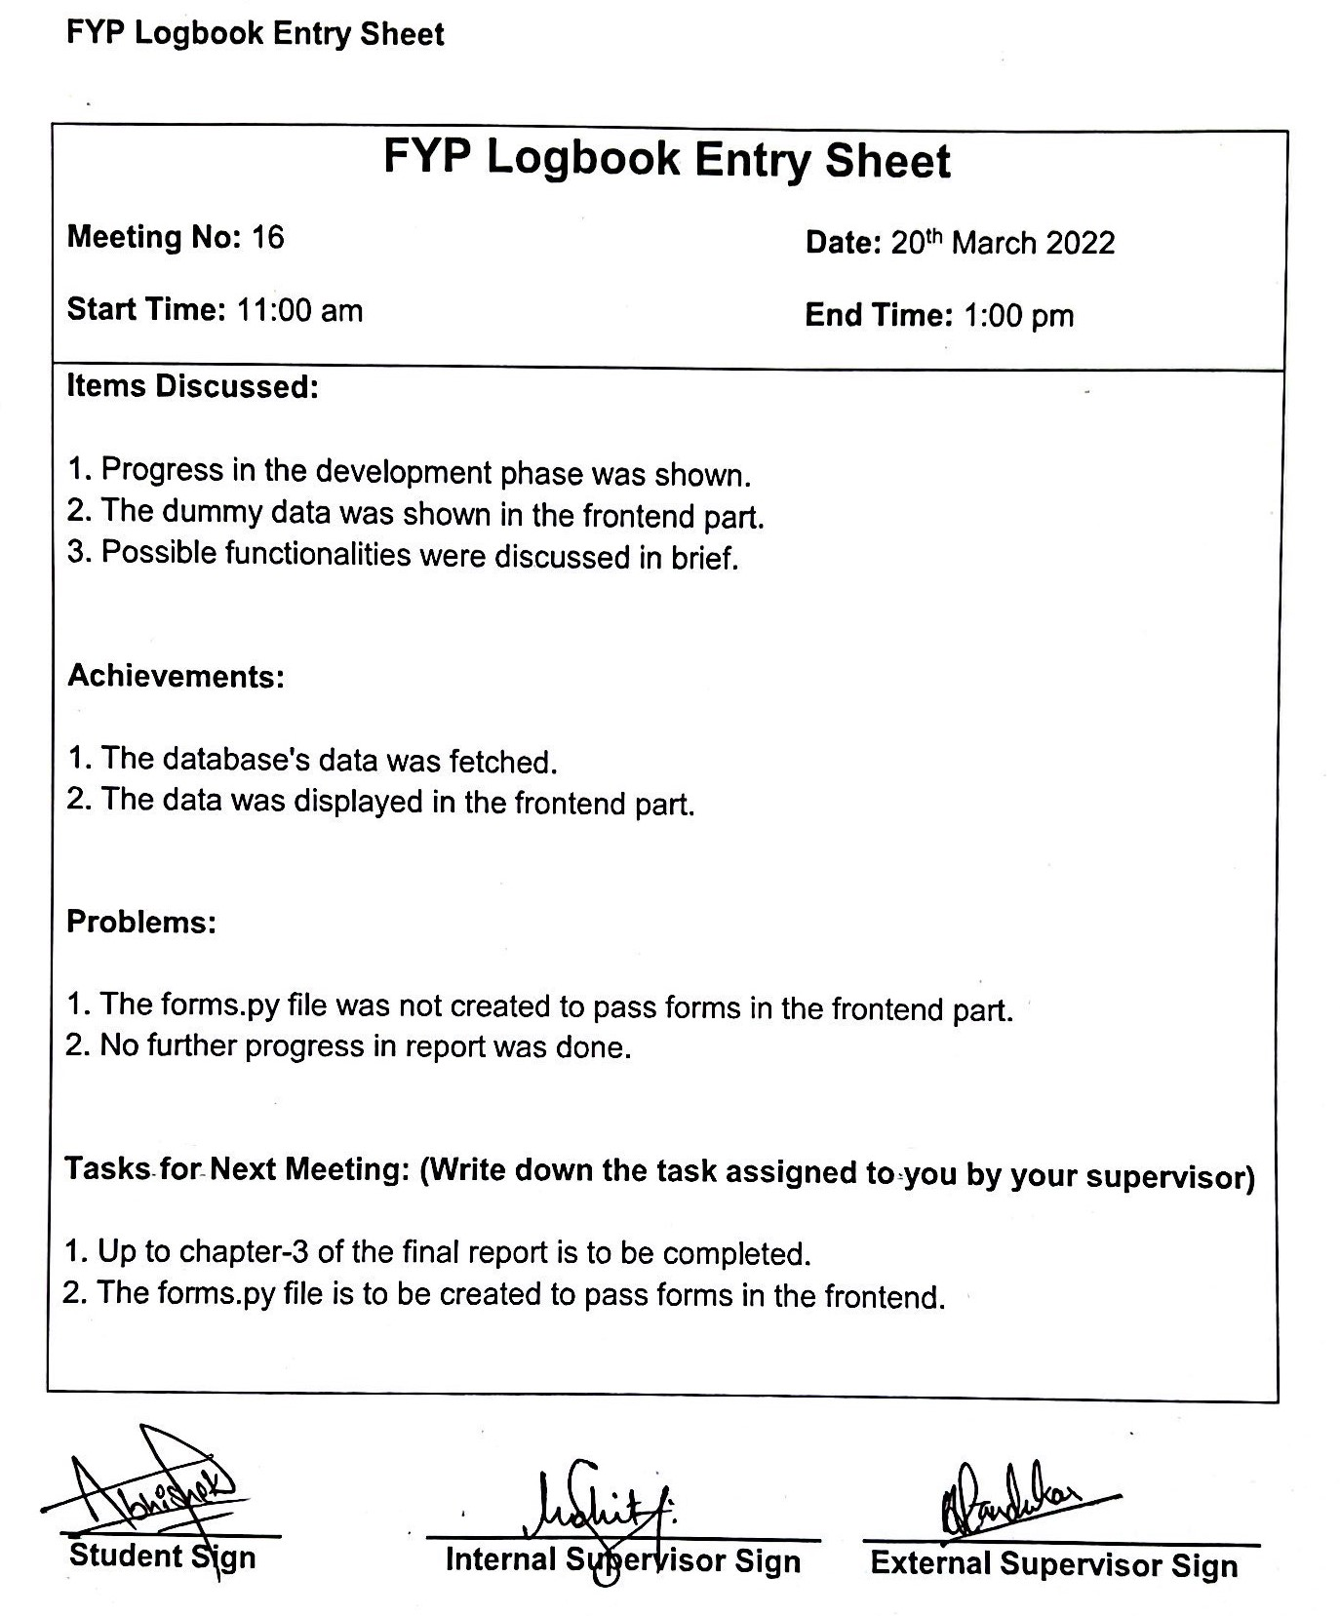

# 13. Log 13

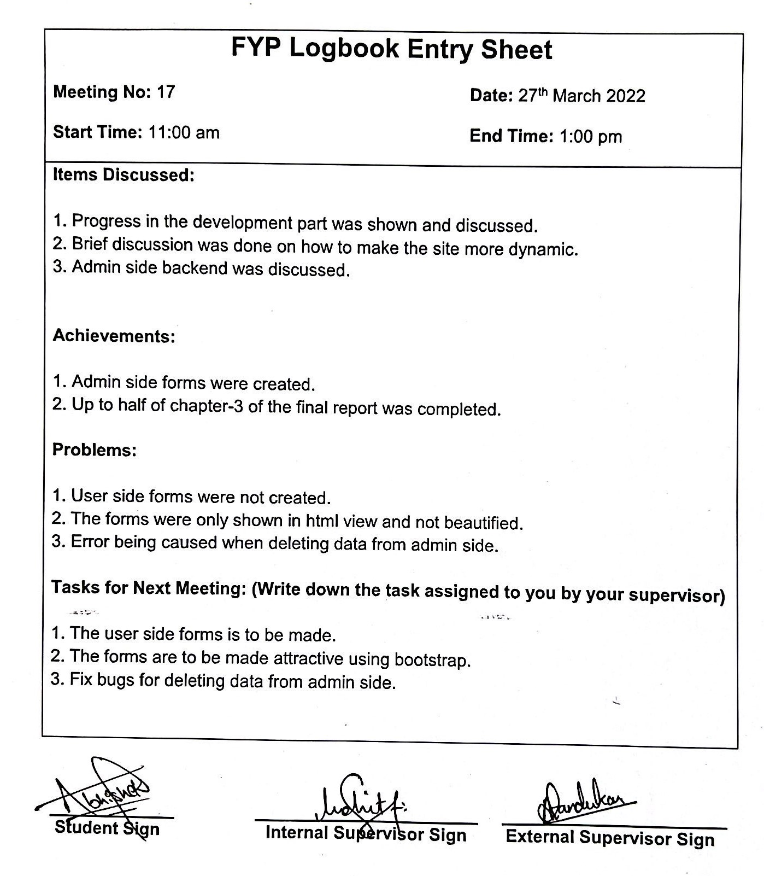

# 14. Log 14

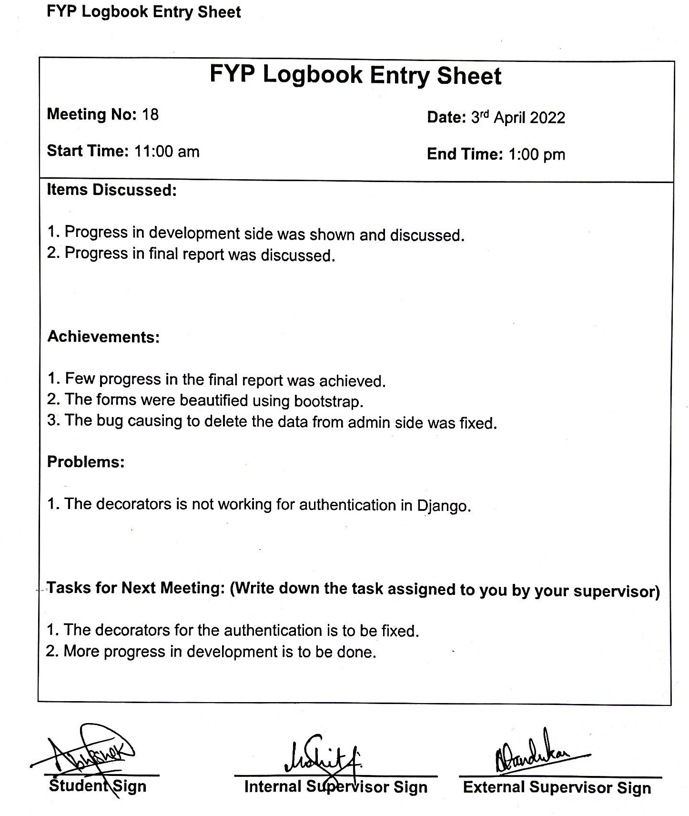

# 15. Log 15

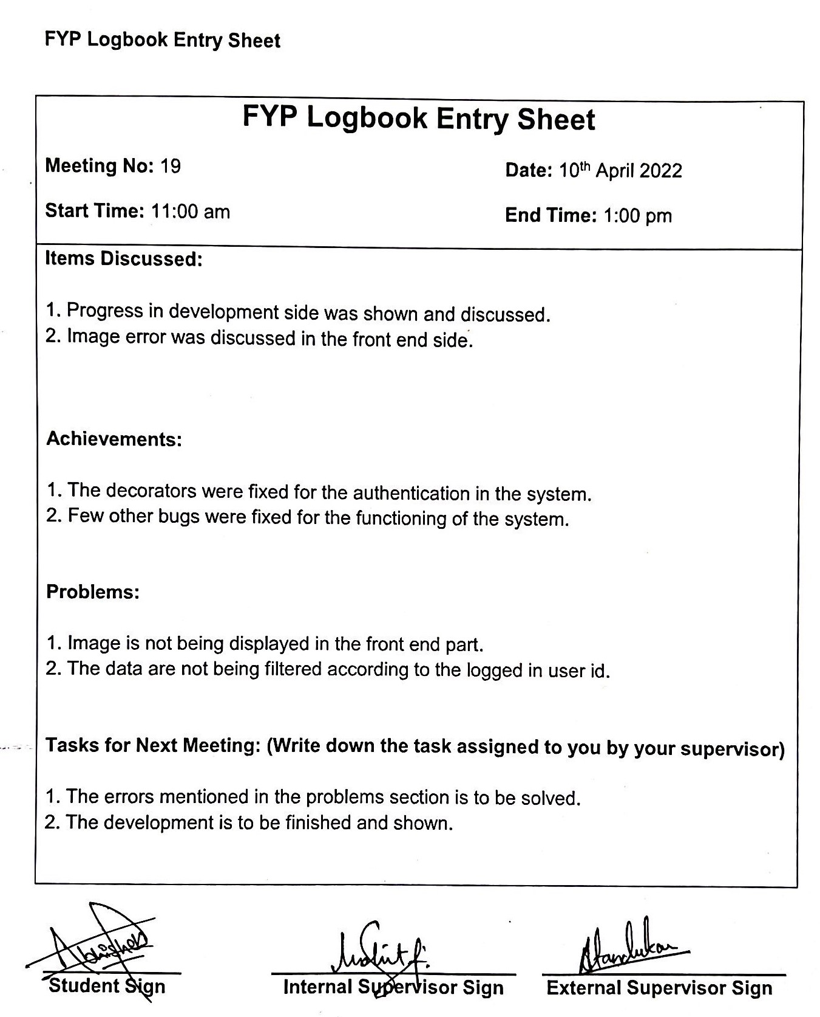

# 16. Log 16

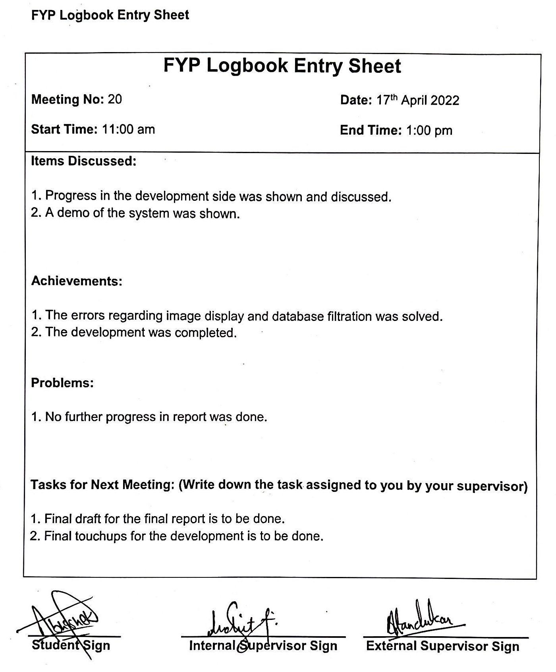

# 17. Log 17

